Q. I. Draw the flow of Instruction cycle.
A program residing in the memory unit of a computer consists of a sequence of instructions. These instructions are executed by the processor by going through a cycle for each instruction.
In a basic computer, each instruction cycle consists of the following phases:
- Fetch instruction from memory.
- Decode the instruction.
- Read the effective address from memory.
- Execute the instruction.
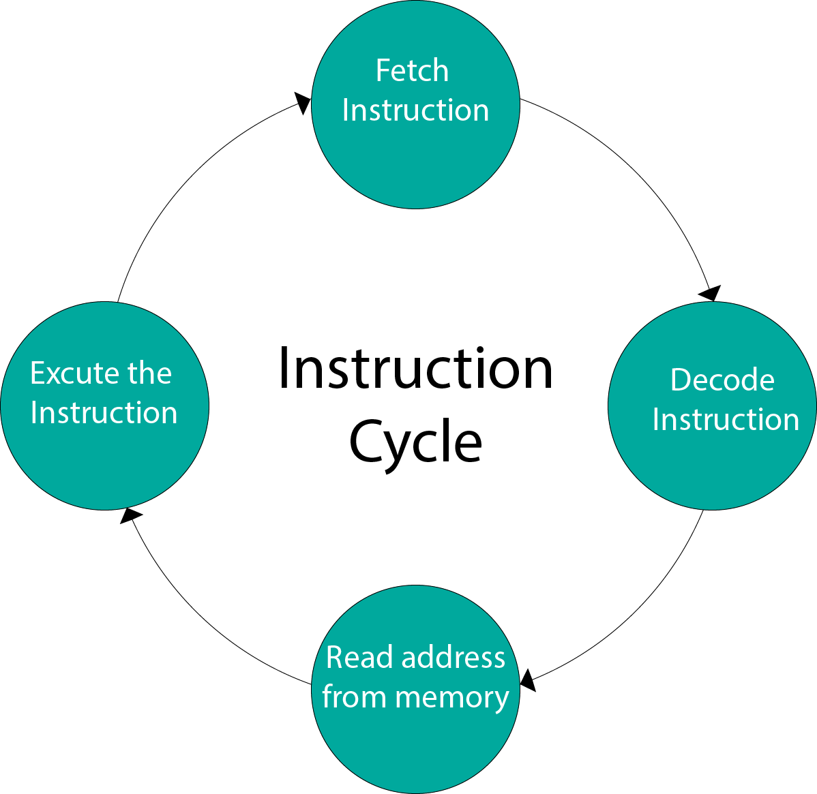
The structure of the instruction cycle defines the processing of a single instruction. The processing of instruction takes various form during the occurrence of an interrupt or if there is indirect addressing present in the instruction. In this section, we will discuss various forms of the instruction cycle.

Instruction Cycle Definition
The processing involved in the execution of a single instruction is termed as Instruction Cycle. This processing is done in two steps i.e. fetch and execute. To execute an instruction the processor first reads an instruction from the memory which is called fetching and then the fetched instruction is executed.
If we discuss the basic structure it includes the following two cycles:
- Fetch cycle: In this cycle, the processor reads the instruction that is to be executed from the memory.
- Execute cycle: In this cycle, the processor interprets the opcode of the fetched instruction and performs the operations accordingly.

Q.2. What is meant by instruction?
A computer instruction is an order given to a computer processor by a computer program. At the lowest level, each instruction is a sequence of 0s and 1s that describes a physical operation the computer is to perform.
Computer instructions typically have three fields. These include an operation code, or opcode, field that identifies the operation to be performed, such as "add" data in memory to a specific register. They also have an address field, showing where registers and memory are located, and a mode field, showing how the registers and memory will perform.
Instructions vary in length. They can be a few bits long or many bytes. A very long instruction word (VLIW) is a processing architecture where the instructions are processed in parallel. VLIW is mostly used in high-performance, embedded applications. Reduced instruction set computer, or RISC, microprocessors are designed to perform a small number of computer instruction types, often of fixed lengths.

How do computer instructions work?
Computer programmers provide the instructions that the computer system needs, using a keyboard or other type of input device. The computer's operating system (OS) or other software applications are programmed to interpret and execute these instructions.
Depending on the particular instruction type, instructions specify special storage areas called registers that may contain data to be used in carrying out an instruction. Instructions also specify the location in computer memory of the data and the input/output (I/O) format to be used.
In a computer's assembler language, each language statement generally corresponds to a single processor instruction. In high-level languages, such as C++, a language statement generally results after the program is compiled in multiple processor instructions.

Q.3.Explain types of operands and type of operations.
Computer instruction is a binary code that determines the micro-operations in a sequence for a computer. They are saved in the memory along with the information. Each computer has its specific group of instructions. They can be categorized into two elements as Operation codes (Opcodes) and Address. Opcodes specify the operation for specific instructions, and an address determines the registers or the areas used for that operation.
Operands are definite elements of computer instruction that show what information is to be operated on. The most important general categories of data are
- Addresses
- Numbers
- Characters
- Logical data

Addresses
Addresses are nothing but a form of data. Here some calculations must be performed on the operand reference in an instruction, which is to determine the physical address of an instruction.

Numbers
All machine languages include numeric data types. Even in non-numeric data processing, numbers are needed to act as counters, field widths, etc. An important difference between numbers used in ordinary mathematics and numbers stored in a computer is that the latter is limited. Thus, the programmer is faced with understanding the consequences of rounding, overflow and underflow.

Characters
A common form of data is text or character strings. While textual data are most convenient for humans. Here are the two common standards, such as:
- American Standard Code for Information Interchange (ASCII)
- Unicode

Logical data
Normally, each word or other addressable unit (byte, half-word, and so on) is treated as a single unit of data. Sometimes, it is useful to consider an n-bit unit consisting of 1-bit items of data, each item having the value 0 or 1. When data are viewed this way, they are considered to be logical data.

Types of operations:
There are two common types of operations: unary and binary. Unary operations involve only one value, such as negation and trigonometric functions.^{[3]} Binary operations, on the other hand, take two values, and include addition, subtraction, multiplication, division, and exponentiation.^{[4]}
Operations can involve mathematical objects other than numbers. The logical values true and false can be combined using logic operations, such as and, or, and not. Vectors can be added and subtracted.^{[5]} Rotations can be combined using the function composition operation, performing the first rotation and then the second. Operations on sets include the binary operations union and intersection and the unary operation of complementation.^{[6][7][8]} Operations on functions include composition and convolution.^{[9][10]}

Q.4.Explain all addressing modes with suitable examples
Addressing Modes– The term addressing modes refers to the way in which the operand of an instruction is specified. The addressing mode specifies a rule for interpreting or modifying the address field of the instruction before the operand is actually executed.
Implied mode:: In implied addressing the operand is specified in the instruction itself. In this mode the data is 8 bits or 16 bits long and data is the part of instruction.Zero address instruction are designed with implied addressing mode.
Example: CLC (used to reset Carry flag to 0)
Immediate addressing mode (symbol #):In this mode data is present in address field of instruction .Designed like one address instruction format.
Example: MOV AL, 35H (move the data 35H into AL register)
Register mode: In register addressing the operand is placed in one of 8 bit or 16 bit general purpose registers. The data is in the register that is specified by the instruction.
Here one register reference is required to access the data.
Example: MOV AX,CX (move the contents of CX register to AX register)
Register Indirect mode: In this addressing the operand’s offset is placed in any one of the registers BX,BP,SI,DI as specified in the instruction. The effective address of the data is in the base register or an index register that is specified by the instruction.
Here two register reference is required to access the data.
MOV AX, [BX](move the contents of memory location s
addressed by the register BX to the register AX)
Auto Indexed (increment mode): Effective address of the operand is the contents of a register specified in the instruction. After accessing the operand, the contents of this register are automatically incremented to point to the next consecutive memory location.(R1)+.
Add R1, (R2)+ // OR
R1 = R1 +M[R2]
R2 = R2 + d
Auto indexed ( decrement mode): Effective address of the operand is the contents of a register specified in the instruction. Before accessing the operand, the contents of this register are automatically decremented to point to the previous consecutive memory location. –(R1)
Add R1,-(R2) //OR
R2 = R2-d
R1 = R1 + M[R2]

Direct addressing/ Absolute addressing Mode (symbol [ ]): The operand’s offset is given in the instruction as an 8 bit or 16 bit displacement element. In this addressing mode the 16 bit effective address of the data is the part of the instruction.
Here only one memory reference operation is required to access the data.
- Example:ADD AL,[0301] //add the contents of offset address 0301 to AL
- Indexed addressing mode: The operand’s offset is the sum of the content of an index register SI or DI and an 8 bit or 16 bit displacement.
Example:MOV AX, [SI +05]
Based Indexed Addressing: The operand’s offset is sum of the content of a base register BX or BP and an index register SI or DI.
Example: ADD AX, [BX+SI]

Q.5.Explain types of instructions with examples
A computer’s instructions can be any length and have any number of addresses. The arrangement of a computer’s registers determines the different address fields in the instruction format. The instruction can be classified as three, two, and one address instruction or zero address instruction, depending on the number of address fields.

Three Address Instructions
A three-address instruction has the following general format:
source 1 operation, source 2 operation, source 3 operation, destination
ADD X, Y, Z
Here, X, Y, and Z seem to be the three variables that are each assigned to a distinct memory location. The operation implemented on operands is ‘ADD.’ The source operands are ‘X’ and ‘Y,’ while the destination operand is ‘Z.’
In order to determine the three operands, bits are required. To determine one operand, n bits are required (one memory address). In the same way, 3n bits are required to define three operands (or three memory addresses). To identify the ADD operation, bits are also required.

Two Address Instructions
A two-address instruction has the following general format:
source and destination of the operation
ADD X, Y
Here X and Y are the two variables that have been assigned to a specific memory address. The operation performed on the operands is ‘ADD.’ This command combines the contents of variables X and Y and stores the result in variable Y. The source operand is ‘A,’ while ‘B’ is used as both a source and a destination operand.
The two operands must be determined using bits. To define one operand, n bits are required (one memory address). To determine two operands, 2n bits are required (two memory addresses). The ADD operation also necessitates the use of bits.

One Address Instructions
One address instruction has the following general format:
operation source
INCLUDE X
Here X refers to the variable that has access to a specific memory region. The operation performed on operand A is ‘ADD.’ This instruction adds the value of variable A to the accumulator and then saves the result inside the accumulator by restoring the accumulator’s contents.

Zero Address Instructions
In zero address instructions, the positions of the operands are implicitly represented. These instructions use a structure called a pushdown stack to hold operands.

Q.6.Explain machine state and processor status.
A state machine is a concept used in designing computer programs or digital logic. There are two types of state machines: finite and infinite state machines. The former is comprised of a finite number of states, transitions, and actions that can be modeled with flow graphs, where the path of logic can be detected when conditions are met. The latter is not practically used.
A state machine is any device storing the status of something at a given time. The status changes based on inputs, providing the resulting output for the implemented changes. A finite state machine has finite internal memory. Input symbols are read in a sequence producing an output feature in the form of a user interface.
State machines are represented using state diagrams. The output of a state machine is a function of the input and the current state. State machines play a significant role in areas such as electrical engineering, linguistics, computer science, philosophy, biology, mathematics, and logic. They are best used in the modeling of application behavior, software engineering, design of hardware digital systems, network protocols, compilers, and the study of computation and languages
The two different groups of state machines are acceptors and transducers. Acceptors produce a binary output, based on whether the input is accepted or rejected by the machine.

Process States
Process states are the states in which the process is currently residing. There are basically five states of processes −
- New − The process is about to be created in this state but not yet created. It is the program which is present in secondary memory that will be picked up by OS to create the process.
- Ready − The process enters the ready state after the creation of a process that means the process is loaded into the main memory.
- Running − The process is chosen by the CPU for instructions and the executions within the process and they are executed by any one of the available CPU cores.
- Waiting − Whenever the process requests access to I/O or needs input from the user or needs access to a critical region it enters the blocked or wait state.
- Terminated − Process is killed as well as PCB (Process Control Box) is deleted.

Q. 7.Give the difference between RISC and CISC architecture.

RISC | CISC
1. RISC stands for Reduced Instruction Set Computer. | 1. CISC stands for Complex Instruction Set Computer.
2. RISC processors have simple instructions taking about one clock cycle. The average clock cycle per instruction (CPI) is 1.5 | 2. CSIC processor has complex instructions that take up multiple clocks for execution. The average clock cycle per instruction (CPI) is in the range of 2 and 15.
3. Performance is optimized with more focus on software | 3. Performance is optimized with more focus on hardware.
4. It has no memory unit and uses separate hardware to implement instructions.. | 4. It has a memory unit to implement complex instructions.
5. It has a hard-wired unit of programming. | 5. It has a microprogramming unit.
6. The instruction set is reduced i.e. it has only a few instructions in the instruction set. Many of these instructions are very primitive. | 6. The instruction set has a variety of different instructions that can be used for complex operations.
7. The instruction set has a variety of different instructions that can be used for complex operations. | 7. CISC has many different addressing modes and can thus be used to represent higher-level programming language statements more efficiently.
8. Complex addressing modes are synthesized using the software. | 8. CISC already supports complex addressing modes
9. Multiple register sets are present | 9. Only has a single register set
10. RISC processors are highly pipelined | 10. They are normally not pipelined or less pipelined
11. The complexity of RISC lies with the compiler that executes the program | 11. The complexity lies in the microprogram
12. Execution time is very less | 12. Execution time is very high
13. Code expansion can be a problem | 13. Code expansion is not a problem
14. The decoding of instructions is simple. | 14. Decoding of instructions is complex
15. It does not require external memory for calculations | 15. It requires external memory for calculations
16. The most common RISC microprocessors are Alpha, ARC, ARM, AVR, MIPS, PA-RISC, PIC, Power Architecture, and SPARC. | 16. Examples of CISC processors are the System/360, VAX, PDP-11, Motorola 68000 family, AMD, and Intel x86 CPUs.
17. RISC architecture is used in high-end applications such as video processing, telecommunications, and image processing. | 17. CISC architecture is used in low-end applications such as security systems, home automation, etc.

